5th Grade Weekly Newsletter
Week of October 17- October 21
Homework
Monday | Tuesday | Wednesday | Thursday | Friday
Math Homework:  Equivalent Fractions Lesson 1 Homework 5.3 Worksheet due Wednesday  S.S. Homework: Chapter 3 Assessment (students may use their books) | LA Homework  Writing: Goals  Reading: The Windmill | Math Homework:  Region Relationships and Cutting Cakes into Eighths due Friday  Science Homework: Science Review | Study vocabulary and spelling words for tests tomorrow | -Spelling and Vocabulary Test Friday  -Green folders go home Friday.
Weekly Vocabulary
Math Vocabulary
Term | English Example | Math Example
equivalent  equal in value | At the present time, one American dollar is equivalent to approximately $1.35 in Canada. | 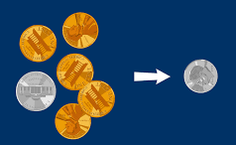
unit fraction  a fraction with a numerator of 1 | Here is how we count $\frac{1}{5}$ s. “One-fifth, two-fifths, three-fifths, and so on. | 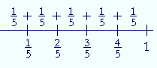
equivalent fraction  fractions that are equal in value | Equivalent fractions look different, but they have the same value.  $\frac{1}{2}$ = $\frac{2}{4}$ = $\frac{4}{8}$ | 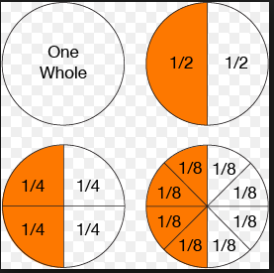
linear model  a line with numbers placed in their correct position |  | 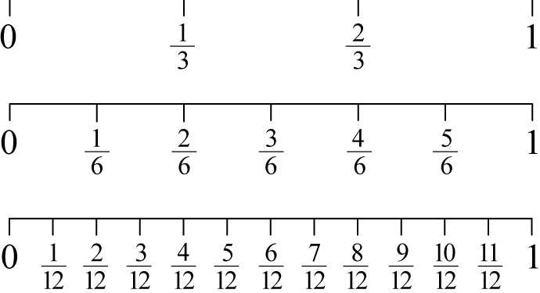
partition  divide into parts | The room partition gives us privacy. | 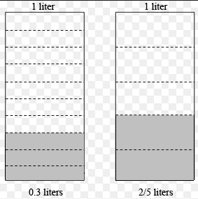
area model  length and width of a rectangle represent the factors | measurement of a surface | 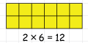
set model  a way to represent a group of things | All of these cards are from the same set.  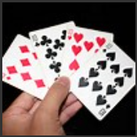 | 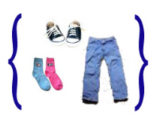 Here is a set of clothing items.
- Fraction: A number that names part of a whole or a part of a group. Example$\frac{5}{12}$
- Denominator: The number below the bar in a fraction that tells how many equal parts are in the whole or in the group. Example $\frac{6}{10}$ - 10 is the denominator.
- Numerator: The number above the bar in a fraction that tells how many equal parts of the whole or group is being considered. Example $\frac{3}{4}$ - 3 is the numerator.
- Equivalent fractions: Fractions that name the same amount or part. Example $\frac{3}{4}$ = $\frac{6}{8}$

Language Arts Vocabulary
- Cause and effect relationship: related events in which one event causes another to occur, sometimes setting off a chain of events.
- Quotation: the exact words spoken by someone
- Domain-specific words: vocabulary commonly used within a given subject area
- Narrative: A story; can be real or imagined.
Social Studies/ Science Vocabulary
Social Studies:
- Ferdinand: king of Spain during the Age of Exploration
- Isabella: queen of Spain during the Age of Exploration
- East Indies: Southeast Asia, including India, Indonesia, and Malaysia
- Christopher Columbus: an explorer from Italy, who became a conquistador
- the Nina, the Pinta, and the Santa Maria: the three ships that the King and Queen of Spain gave to Columbus to use for exploring the New World
- captive: a person who has been taken prisoner
- John Cabot: a merchant from Italy who explored the New World for the King of England
- Ponce de Leon: a Spanish explorer who searched for the “fountain of youth;” known also for founding Florida
- Cortés: a Spanish nobleman living in Cuba, sailed to Mexico in search of adventure and wealth
- Jacques Cartier: a French explorer who set sail to find the Northwest Passage
- Coronado: explorer for Mexico, who searched for the Seven Cities of Gold and known for his brutal treatment of Native Americans and slaves
- Henry Hudson: English explorer known for finding a large bay in North America and claiming land in eastern Canada for England
- La Salle: French explorer who explored the Mississippi River and named the vast region he had crossed Louisiana, for the French king
- founded: to establish or begin

Science Vocabulary: We will be reviewing all terms and learning targets this week.
Spelling Words (Study words for test on Friday)
- destroy
- saucer
Challenge:
- accumulate
- achievement
- acquaintance

- pounce
- poison
- august
- auction
- royal
- coward
- awkward
- encounter
Math News
We are continuing our unit on fractions. We are working to develop a conceptual understanding with models and manipulatives. Our class got a project funded on Donors Choose so we have been given amazing fraction manipulatives that will be used throughout our entire fraction unit. Students will be writing thank you letters in the upcoming weeks to our donors for funding our project and getting students the materials needed to be successful! This will give students a strong foundation for all the fraction operations and real world fraction problems we will be doing in 5th grade math. Students have not been tested on any of the fraction vocabulary and will have a test this Friday. Get on Reflex if you haven’t mastered your basic math facts. If you have questions or concerns please feel free to contact me at amy.cook@jefferson.kyschools.us

Language Arts News
This week we wrap up poetry and write narratives on demand. In our informational and literary stories, we will summarize and explain how characters respond to challenges or how the speaker reflects on a topic. We answer literal comprehension questions and also infer and explain this week. This is the start of a new grading period! Students need to read daily, get on COMPASS LEARNING reading at home, and participate in class. A new project will be sent home next week. Please email me with any questions: Elizabeth.pitt@jefferson.kyschools.us

Social Studies/ Science News We are continuing our unit on New World Exploration and Colonization. We will focus on this essential question: What did explorers take to and from the New World during the Age of Exploration?
Donations for the Fall Festival baskets are due by Thursday. The theme for our basket is “healthy snacks.” Please consider donating! Fifth graders will be sponsoring the Haunted Hallway this year. Don’t miss the fun! Meet in room 110 on Friday, Oct. 21st to take part! Thanks in advance for your support. You can email me at: beth.macaluso2@jefferson.kyschools.us

Announcements
- Fifth grade students who were referred for AP testing, test this week.
- HAUNTED HALLWAY student permission slips due by Wednesday.
- PARENTS / GUARDIANS, please come to Room 110 at 4:00 pm if you are able to help for the HAUNTED HALLWAY, on FRIDAY.
- PLEASE send in healthy snack items for our FALL FESTIVAL BASKET, as soon as possible.
- Fall Festival, this FRIDAY! See you there from 6:00 – 8:30 pm.
- Report cards will be sent home FRIDAY. Please sign and return envelope on Monday.
- RED RIBBON WEEK is next week!

