5th Grade Weekly Newsletter
Week of October 24- October 28
Homework
Monday | Tuesday | Wednesday | Thursday | Friday
Math Homework:  Fraction Models Riddle Worksheet pg. C-20 and C-21 Due Wednesday Must write math answers and not just do the riddle.  S.S. Homework:  Chapter 4 Assessment (students may use their books) | LA Homework  Writing: One Item paragraph  Reading: In daddy’s arms | Math Homework  Fraction Models Riddle Worksheet pg. C-22 and C-24 Due Friday. Must write math answers and not just do the riddle.  Science Homework: Dry Ice: Evaporation vs Sublimation | Study vocabulary and spelling words for tests tomorrow | -Spelling and Vocabulary Test Friday  -Green folders go home Friday.
Weekly Vocabulary
Math Vocabulary
Term | English Example | Math Example
equivalent  equal in value | At the present time, one American dollar is equivalent to approximately $1.35 in Canada.
unit fraction  a fraction with a numerator of 1 | Here is how we count $\frac{1}{5}$ s. “One-fifth, two-fifths, three-fifths, and so on. | 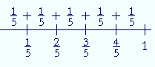
equivalent fraction  fractions that are equal in value | Equivalent fractions look different, but they have the same value.  $\frac{1}{2}$ = $\frac{2}{4}$ = $\frac{4}{8}$ | 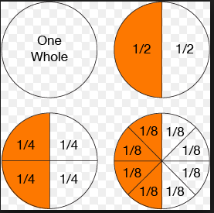
linear model  a line with numbers placed in their correct position |  | 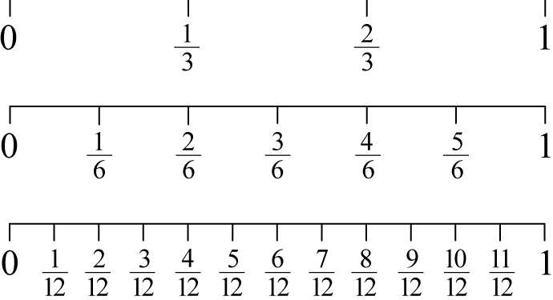
partition  divide into parts | The room partition gives us privacy. | 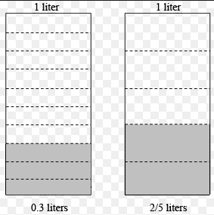
area model  length and width of a rectangle represent the factors | measurement of a surface | 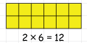
set model  a way to represent a group of things | All of these cards are from the same set.  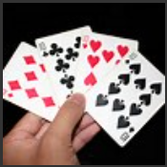 | 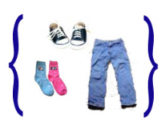 Here is a set of clothing items.
- Fraction: A number that names part of a whole or a part of a group. Example$\frac{5}{12}$
- Denominator: The number below the bar in a fraction that tells how many equal parts are in the whole or in the group. Example $\frac{6}{10}$ - 10 is the denominator.
- Numerator: The number above the bar in a fraction that tells how many equal parts of the whole or group is being considered. Example $\frac{3}{4}$ - 3 is the numerator.
- Equivalent fractions: Fractions that name the same amount or part. Example $\frac{3}{4}$ = $\frac{6}{8}$

Language Arts Vocabulary
There are no new Language Arts Vocabulary words this week
Social Studies/ Science Vocabulary
Social Studies Vocab:
- assembly: a group of government officials who meet to make laws
- claim: declaring control or ownership of land or property
- economy: the wealth and resources of a country or region
- founded: established or originated, began
- government: a system of rules that a country, state, or community follows
- Mayflower Compact: An agreement made by the Pilgrims while on the Mayflower in 1620, just before they landed at Plymouth Rock, which bound them to live in a civil society according to their own laws
- The Middle Passage: the route of the slave trade of Africans across the Atlantic Ocean to the Americas
- supply: the amount of a good that you have to sell
- demand: the desire for a good or product
- proprietary colony: a colony or property that is ruled by one person who has been chosen by the King to make rules and govern the land
- charter colony: were self-governing colonies who had an agreement with the King describing the responsibilities and privileges of both the King and the colonists
Science Vocabulary:
- germination: the process by which a plant grows from a seed
- terrarium: a sealed transparent globe or similar container in which plants are grown
- nutrients: a substance that provides nourishment necessary for growth and all life

Science Extra: In Science, we will cover the following learning targets for the next two weeks:
- I can describe the process that forms plant matter. (PS3.D)
- I can use evidence to explain where plants acquire what they need for growth. (LS1.C)
- We will take our Science Proficiency test this week and enjoy a Halloween experiment.

Spelling Words (Study words for test on Friday)
- barely
- aboard
- absorb
- vary
- perform
- soar
- barge
- stairway
- ordeal
- presence

Challenge:
- accumulate
- achievement
- acquaintance
Math News
Continue to study your fraction math vocabulary. You will have a quiz over the definitions this week. Students are getting much better at understanding fractions. They are persevering even when the fraction problems are difficult. They are thinking through the problems and constructing models and critiquing the reasoning of their classmates. The homework this week is all about modeling with fractions to develop of deeper understanding of the meaning of fractions. Get on reflex daily at home if you haven’t achieved 100% fluency of basic math facts. If you have any questions feel free to contact me through email at amy.cook@jefferson.kyschools.us.
Language Arts News
This week students summarize and find the theme from a fictional story. Also, we will explain relationships and interactions between two or more individuals, events, ideas or concepts in text. We begin informational writing this week. Students need to read daily, get on COMPASS LEARNING reading at home, and participate in class. A reading / writing project was sent home today. Please email me with any questions: Elizabeth.pitt@jefferson.kyschools.us

Social Studies/ Science News
- Social Studies/ Science News: We will be continuing our colonial study this week and moving toward the causes and effects of events leading to the American Revolution. In Science, we will begin a new unit: “Matter and Energy in Organisms and Ecosystems.
- The Fall Festival was a great time for getting to know the students! Thank you to all the parents that helped with the Haunted Hallway! Monday, October 31st, you are invited to come walk with us during our school-wide Halloween Parade. The fifth graders will be “parading” with our 2nd grade little buddies and we will be trick-or-treating afterwards. We will enjoy a healthy snack and a good movie afterwards. You are welcomed to join us!
- Thanks to all the parents that were able to donate to the Fall Festival!
- Please be sure to sign and return the report card envelope as we use it all year. Students who will be receiving a Lion’s Pride award received a note in their report card. You are encouraged to attend the short award’s ceremony. beth.macaluso2@jefferson.kyschools.us
- Social Studies/ Science News: We will be continuing our colonial study this week and moving toward the causes and effects of events leading to the American Revolution. In Science, we will begin a new unit: “Matter and Energy in Organisms and Ecosystems.
- The Fall Festival was a great time for getting to know the students! Thank you to all the parents that helped with the Haunted Hallway! Monday, October 31st, you are invited to come walk with us during our school-wide Halloween Parade. The fifth graders will be “parading” with our 2nd grade little buddies and we will be trick-or-treating afterwards. We will enjoy a healthy snack and a good movie afterwards. You are welcomed to join us!
- Thanks to all the parents that were able to donate to the Fall Festival!
- Please be sure to sign and return the report card envelope as we use it all year. Students who will be receiving a Lion’s Pride award received a note in their report card. You are encouraged to attend the short award’s ceremony. beth.macaluso2@jefferson.kyschools.us

Announcements
- RED RIBBON WEEK is this week!
- THANK YOU for your help with the Haunted Hallway!
- Blue jean day is Friday, $1.00 donation for the Crusade for Children!
- Lion’s Pride Award ceremony is Friday from 11:50 – 12:20. See you there!
- We have many donations for the October 31st Halloween Parade, thank you!
- October 31st, students may wear their costumes to school for a $5.00 donation. We will have a parade and healthy trick or treat stations.
- Nov. 7-8, No school

